**Spring Boot** is used to create spring stand-alone applications using Java.

It eliminates manual work

Spring Boot is doing auto configuration

You don’t need tom cat server,

In previous, we need to install tomcat and then our endpoint go to that server. But, now spring boot have embedded tom cat server in it.

Bean is an object that we configure first time and then whole codebase use it. In previous, we need to manually configure the bean. But, now a days, we don’t need to configure it. We can do it by using bean.

Build tool compiles, test and packages. (automates the things).

It converts our project into jar or either war

Dependency is something you are using others code like you interact with database, or pics modification adding color on them.

JAR is java archieable, it runs through one command.

### **JRE (Java Runtime Environment)**

The **Java Runtime Environment (JRE)** is a software package that provides the necessary environment to run Java applications. It is a part of the larger **Java Development Kit (JDK)** and is specifically designed for end-users to run Java programs without needing to write or compile them.

### **Key Components of JRE:**

**Java Virtual Machine (JVM):**

* 1. The core of the JRE.
  2. Executes the bytecode (compiled .class files) and provides platform independence.
  3. Handles memory management, garbage collection, and other runtime tasks.

**Class Libraries:**

* 1. A collection of pre-written Java classes that provide essential functionality for Java programs, such as:
     1. File I/O operations
     2. Networking
     3. GUI creation (Swing, AWT)
     4. Utility functions (e.g., collections, math)
  2. Found in rt.jar (runtime libraries).

**Class Loader:**

* 1. Loads Java classes into the JVM dynamically at runtime.

**Runtime Libraries (Native Libraries):**

* 1. Includes native libraries (.dll on Windows, .so on Linux) that support the execution of Java programs.

### **JRE vs. JDK vs. JVM**

| **Component** | **Purpose** |
| --- | --- |
| **JVM** | Executes Java bytecode; part of the JRE. |
| **JRE** | Provides everything needed to **run Java applications**, including the JVM, class libraries, and runtime. |
| **JDK** | A superset of the JRE; provides tools for **developing** Java applications, such as the compiler (javac). |

### **When Do You Need JRE?**

* If you are **running** Java applications but not writing or compiling them.
* For example:
  + Running a .jar file with the command:

java -jar application.jar

### **How It Works:**

1. The JRE uses the JVM to load and interpret the .class file or .jar file containing the Java bytecode.
2. The bytecode is converted into machine code at runtime by the JVM, making the program executable on your system.

### **Key Features of JRE:**

* **Platform Independence:** Java programs run on any system with a JRE installed.
* **Automatic Memory Management:** Built-in garbage collection manages memory allocation and cleanup.
* **Built-in Libraries:** Provides a vast set of APIs for common programming tasks.

In short, the JRE is the runtime environment that bridges the gap between Java code and the machine it's running on!

Tomcat started on port 8080 (http) with context path '/'

After opening it on, you’ll see something there

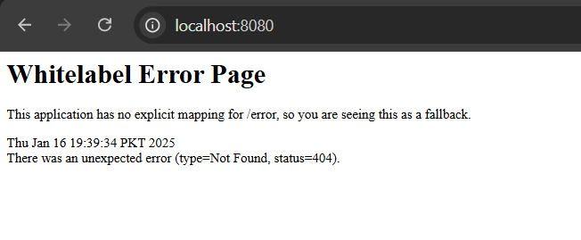

PID 14224 is assigned to my machine.